Video Reflection: Rainy Hike

Using video to support reflective practices:
Video demonstrations are commonly used to support pre-service and in-service practitioners’ observations and reflections (Marsh & Mitchell, 2013). Research has demonstrated that when professional development is provided through the effective use of videos, it can increase early intervention and early childhood special education professional’s understanding of teaching practices and foster reflection about their own practices (Major & Watson, 2018). This guide uses video clips as well as a list of reflective questions to help you identify ways to promote STEM learning for all children.

Video Description:
In the video clip, Henry and his mom are taking a hike outside on a rainy day. Henry is curious about everything around him.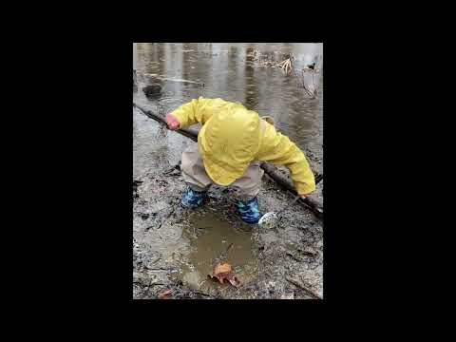

Reflection Questions:
As you watch the video for the first time, think about what you notice related to the child’s thinking/engagement, and how the adult guides and supports the child.
- While watching Henry play with the mud, what do you observe about his understanding of cause and effect? How is Henry engaging in the practice of observing?
Hint: Pay attention to children’s actions/behaviors and verbal responses.
- How does Henry’s mom scaffold his understanding of properties of earth materials during this experience? What are some examples?
Hint: Think about what Henry’s mom said and asked.
- How would you scaffold Henry’s understanding of cause and effect in your own practice?
- How would you support Henry’s mom to help Henry develop higher levels of scientific knowledge and thinking?
The contents of this resource were developed under a Cooperative Agreement between the U.S. Department of Education, Office of Special Education Programs (OSEP) and the University of North Carolina at Chapel Hill. #H327G180006. These contents do not necessarily represent the policy of the U.S. Department of Education, and you should not assume endorsement by the Federal Government.

