Video Reflection: Fun with Ramps-Supporting children’s understanding of force and motion

Using video to support reflective practices:
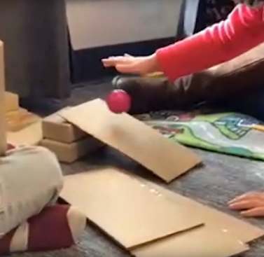
Video demonstrations are commonly used to support pre-service and in-service practitioners’ observations and reflections (Marsh & Mitchell, 2013). Research has demonstrated that when professional development is provided through the effective use of videos, it can increase teachers’ understanding of teaching practices and foster reflection about their own practices (Major & Watson, 2018). This guide uses video clips as well as a list of reflective questions to help practitioners identify ways to promote STEM learning for all children and reflect on how they can be applied in their own classrooms.

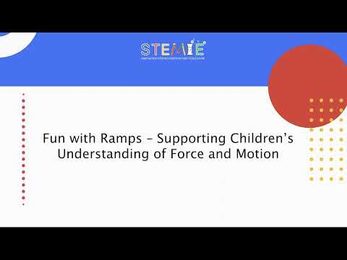
Video Description:
The video clip shows how two preschoolers in an inclusive early childhood classroom are engaging in a STEM learning experience at center time with a STEMIE team member, Jaclyn. She is supporting the children’s understanding of the Physical Science concept of force and motion.
The child on the left hand side of the video typically enjoys playing in the block center. One of the main IEP goals for this child is to support his communication skills during play with peers and adults.

Reflection Questions:
As you watch the video the first time, think about what you notice about the children’s thinking, engagement, and the adult scaffolding?
- What do you notice about the children’s understanding of force and motion as they engage with the materials?
Hint: Pay attention to children’s actions/behaviors and verbal responses.
- How does the adult (Jaclyn) scaffold the children's understanding of force and motion during this experience? What are some examples?
Hint: Think about what Jacklyn said and asked.
- How does the adult (Jaclyn) foster inclusion in this experience?
Hint: Think about the context of the activity.
- How does the adult (Jaclyn) support the child’s IEP goal?
Hint: Think about what teaching strategies and instructional adaptations Jaclyn used.
- How would you incorporate adaptations in this experience?
- How could you scaffold children’s understanding of force and motion and participation in STEM learning experiences in your own practice?

Note: Scaffold refers to providing “prompts and hints to support the learner and then gradually withdraw these supports as the learner performs with increased independence.” (Bodrova & Leong, 2012)
The contents of this resource were developed under a Cooperative Agreement between the U.S. Department of Education, Office of Special Education Programs (OSEP) and the University of North Carolina at Chapel Hill. #H327G180006. These contents do not necessarily represent the policy of the U.S. Department of Education, and you should not assume endorsement by the Federal Government.

