Video Reflection: Storybook Preparation

Using video to support reflective practices

**Video demonstrations are commonly used to support pre-service and in-service practitioners’ observations and reflections (Marsh & Mitchell, 2013). Research has demonstrated that when professional development is provided through the effective use of videos, it can increase early intervention and early childhood special education professional’s understanding of teaching practices and foster reflection about their own practices (Major & Watson, 2018). This guide uses video clips as well as a list of reflective questions to help you identify ways to promote STEM learning for all children.**

Video Description:

**The video clip shows a teacher using a story box to support children’s understanding of STEM concepts before story time. A story box is a container (e.g., basket, box, plastic bin) of objects (e.g., puppets, stuffed animals) related to the story and is used to increase engagement and understanding of the story.**

Video:

**[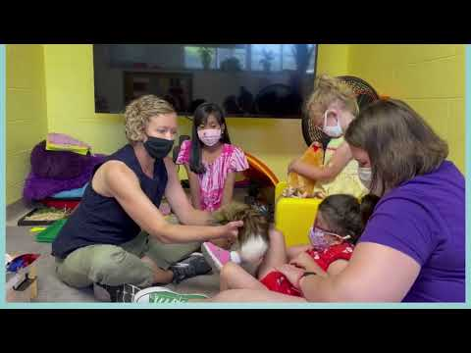](https://www.youtube.com/embed/FwlC4lyEZ9U?feature=oembed)**

Reflection Questions:

**As you watch the video for the first time, think about what you notice about the children’s thinking, engagement, and the adult scaffolding?**

* **What do you notice about the children’s engagement and their understanding of the STEM vocabulary during this experience?**

***Hint: Pay attention to children’s actions/behaviors and verbal responses.***

* **How does the teacher support children’s understanding of STEM concepts before story time? What are some examples?**

***Hint: Think about what adaptations, STEM vocabulary, teaching practices that the teacher used in the video.***

* **How else would you prepare children to engage in STEM learning and understanding of content before story time?**
* **How would you use a story box in your own practice?**

The contents of this resource were developed under a Cooperative Agreement between the U.S. Department of Education, Office of Special Education Programs (OSEP) and the University of North Carolina at Chapel Hill. #H327G180006. These contents do not necessarily represent the policy of the U.S. Department of Education, and you should not assume endorsement by the Federal Government.

